**Object Tracking Self Balanced Robot**

INTRODUCTION:

**SELF BALALNCING:**

The basics behind a balancing robot is based on the [Inverted Pendulum c](http://en.wikipedia.org/wiki/Inverted_pendulum)oncept. The goal is to have a control algorithm called Proportional Integral Derivative [(PID) t](http://en.wikipedia.org/wiki/PID_controller)o keep the robot balanced by trying to keep the wheels under the center of gravity. Eg. If the robot leans forwards, the wheels spin forward trying correct the lean.

**OBJECT TRACKING:**

Image Processing has been the talk of e-world for some years. Its varied applications have found its uses in almost every field.In Electrical Engineering and ComputerScience, image processing is any form of signal processing for which the input is an image, such as photographs or frames of video; the output of image processing can be either an image or a set of characteristics or parametersrelated to the image. Most image- processing techniques involve treating the image as a two-dimensionalsignaland applying standard signal- processing techniques to it.Robotic Vision deals with image processing and Computer Vision. The whole idea behind robotic vision is: viewing an object from the robot’s perspective, deciding on object of interest and to act accordingly

HARDWARE REQUIRED:

Raspberry Pi 2

Motors (2): 5V operated and **Wheels(2)**

Robot Chassis

Motor Driver IC – L293

Camera module

Gyro+Accelerometer Sensor- MPU-6050

Battery – 6LR61 (9V)

Jumper Wires

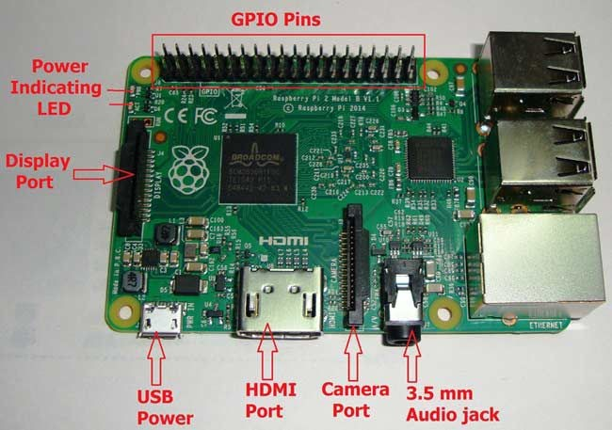**COMPONENT DESCRIPTION:**

**7. Raspberry Pi 2:**

“Pi is a single-board computer”. Pi is a small scale computer in the size little bigger than a credit card, it packs enough power to run games, word processor like open office, image editor like Gimp and any program of similar magnitude.

Pi was introduced as an educational gadget to be used for protyping by hobbyists and for those who want to learn more about programming. It

certainly cannot be a substitute for our day to day

Linux, Mac or Windows PC.

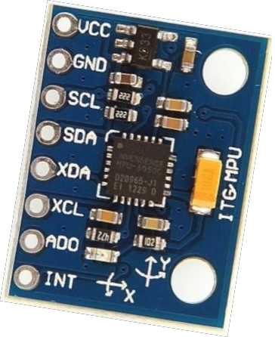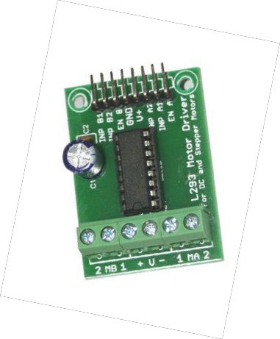Pi is based on a Broadcom SoC (System of Chip) with an ARM processor [~700 MHz], a GPU and 256 to 512 MB RAM. The boot media is an SD card [which is not included], and the SD card can also be used for persist data.

**8. Motor Driver IC – L293**

It is a motor driver which can provide bi-directional drive current for two motors.With bi-directional current, we can move the two motors in either direction i.e. forward, backward, left, right, clockwise rotation, anticlockwise rotation.

**9. Gyro+Accelerometer Sensor- MPU-6050**

The MPU-60X0 is the world’s first integrated 6- axis MotionTracking device that combines a 3- axis gyroscope, 3-axis accelerometer, and a Digital Motion Processor™ (DMP)

The MPU-60X0 features three 16-bit analog-to-digital converters (ADCs) for digitizing the gyroscope outputs and three 16-bit ADCs for digitizing the accelerometer outputs. For precision tracking of both fast and slow motions, the parts feature a user-programmable gyroscope full-scale

range of ±250, ±500, ±1000, and ±2000°/sec (dps) and a user-programmable accelerometer full-scale range of ±2g, ±4g, ±8g, and ±16g.

**10. Camera Module**

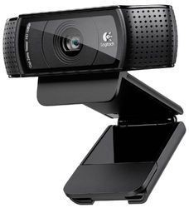

**OpenCV**

OpenCV (Open Source Computer Vision Library) is released under a BSD license and hence it’s free for both academic and commercial use. It has C++, C, Python and Java interfaces and supports Windows, Linux, Mac OS, iOS and Android. OpenCV was designed for computational efficiency and with a strong focus on real-time applications. Written in optimized C/C++, the library can take advantage of multi-core processing. Enabled with OpenCL, it can take advantage of the hardware acceleration of the underlying heterogeneous compute platform

Future Improvements:

Fix the wobble by setting a minimum PWM duty cycle that is just below the threshold at which the motors begin to spin. That will get rid of the current deadspot in which the motors don't spin for a number of degrees.

Fix the asymmentry in the motor speeds. That likely has to do with friction, so using machine oil to lubricate one or both of the motors might fix the problem.

Add encoders to the robot to allow it to measure and control its speed. That will prevent it from approaching its maximum speed and falling over.

Implement automatic tilt calibration so that the robot will always remain balanced even if its center of gravity is shifted, requiring no action by the user.

Implement manual remote steering of the robot, commanding it to move forward, backward, and rotate clockwise or counter-clockwise.

Add a light sensing system to the bottom of the robot and make it autonomously follow a dark path drawn on the ground.

Applications of Object Tracking Robot:

Mobile robots, driver assistance

Cell phone location or object reognition

Augmented Reality